Homework M2

I am creating a CentOS VM with Docker installed with the following vagrant file and shell script:

Vagrant file - <https://pastebin.com/dK175Pmn>

Shell script -  [https://pastebin.com/wXbzAcaL](%20https://pastebin.com/wXbzAcaL)

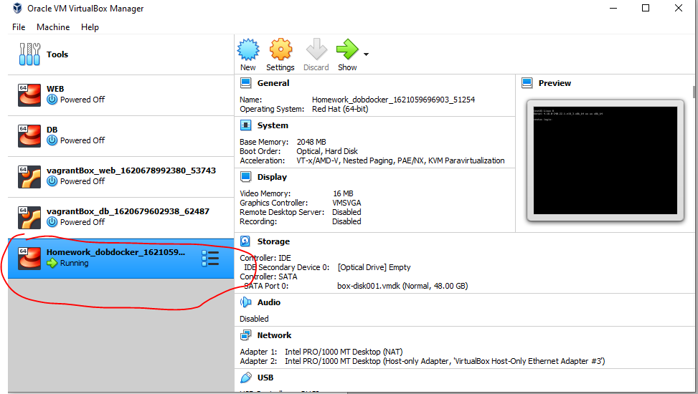

My container will be based on Ubuntu.

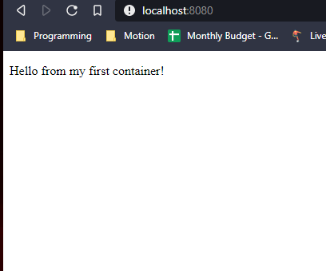

Dockerfile - <https://pastebin.com/bHnYnyFd>

Index.html - <https://pastebin.com/N5V4NS70>